AI Project Deployment & Capstone
Breast Cancer Diagnosis Predictor: An End-to-End Machine Learning Application Deployed with Flask
Week 4 Task — Project Report
Submitted by: Sharvin Chaure
October 2026

1. Abstract
This report documents the design, implementation, evaluation and deployment of an end-to-end machine learning application that predicts whether a breast tumour is malignant or benign from 30 numerical measurements of cell nuclei. The project covers every stage of the machine learning lifecycle: data inspection and preprocessing, comparison of three candidate algorithms, hyper-parameter tuning, evaluation on a held-out test set, model serialization with Joblib and Pickle, and deployment as a REST API with a browser-based interface built using Flask. The final model, a standardised Logistic Regression classifier, reached 97.4% accuracy, 98.6% recall and a ROC-AUC of 0.996 on unseen data. The application is covered by automated tests, packaged with Docker and documented in a GitHub-ready repository.

2. Introduction and Objectives
Building a model in a notebook is only half of a real machine learning project; a model creates value only when other people and systems can use it. The objective of this capstone is therefore to take a model from raw data all the way to a working, tested prediction service. The specific objectives were:
- Build an end-to-end machine learning project covering data preprocessing, model training, testing and deployment using Flask.
- Serialize the trained model with Pickle and Joblib and load it inside a simple prediction API.
- Deliver a complete application with project documentation and a presentation.
Breast cancer diagnosis was selected because it is a well-studied binary classification problem with a clean, publicly available dataset, which lets the focus remain on engineering and deployment practice rather than data collection.

3. Dataset
The project uses the Wisconsin Diagnostic Breast Cancer dataset, distributed with scikit-learn. Each record describes a digitised image of a fine-needle aspirate of a breast mass. Ten properties of the cell nuclei (radius, texture, perimeter, area, smoothness, compactness, concavity, concave points, symmetry and fractal dimension) are summarised by their mean, standard error and worst value, giving 30 numeric features per patient.
Property | Value
Samples | 569
Features | 30 (all numeric)
Target | 0 = malignant (212 samples), 1 = benign (357 samples)
Missing values | None
Train / test split | 80% / 20% stratified (455 / 114 samples), random_state = 42

4. Methodology

4.1 Data preprocessing
The data was checked for missing values and duplicates (none found). The classes are moderately imbalanced (about 63% benign), so a stratified split was used to preserve the class ratio in both the training and test sets. The features sit on very different scales (for example, mean area is in the hundreds while mean smoothness is below 0.2), so all features are standardised with StandardScaler. To prevent data leakage, the scaler is placed inside a scikit-learn Pipeline together with the classifier; it is fitted only on training folds during cross-validation and the whole pipeline is serialized as a single object, which guarantees that exactly the same preprocessing is applied at prediction time.

4.2 Model selection
Three algorithms were compared using 5-fold cross-validation on the training set only, keeping the test set untouched until the final evaluation.
Model | CV accuracy (mean) | Std. deviation
Logistic Regression | 98.02% | ± 1.28%
SVM (RBF kernel) | 97.14% | ± 1.79%
Random Forest (200 trees) | 95.82% | ± 1.62%
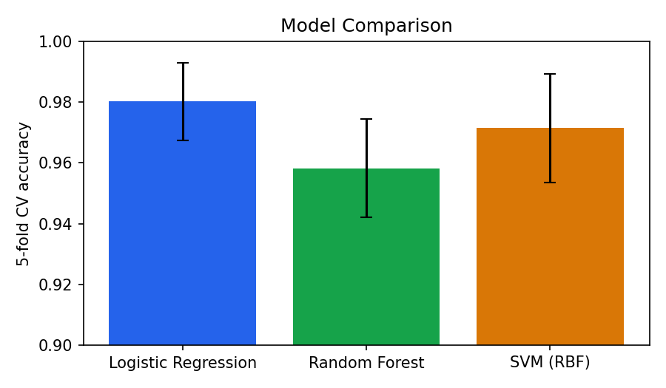
Figure 1: Cross-validated accuracy of the candidate models
Logistic Regression achieved the best and most stable cross-validation score. Besides accuracy, it is fast, small to serialize, and interpretable, which are valuable properties for a medical-style application.

4.3 Hyper-parameter tuning
GridSearchCV with 5-fold cross-validation searched the regularisation strength C over {0.01, 0.1, 1, 10, 100}. The best value was C = 0.1, indicating that moderately strong regularisation helps generalisation on this correlated feature set.

5. Results
The tuned pipeline was evaluated once on the 114 held-out test samples.
Metric | Test score
Accuracy | 97.37%
Precision (benign) | 97.26%
Recall (benign) | 98.61%
F1-score | 97.93%
ROC-AUC | 0.9957

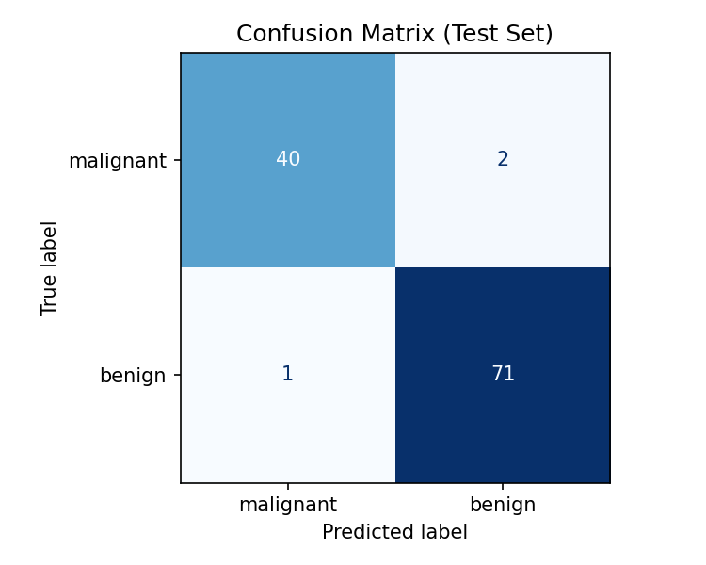
Figure 2: Confusion matrix on the test set
Only 3 of 114 test samples were misclassified. Per-class results were: malignant precision 0.98 and recall 0.95 (42 samples); benign precision 0.97 and recall 0.99 (72 samples). In a real diagnostic setting, missing a malignant tumour is the costlier error, so future work should tune the decision threshold to favour malignant recall.
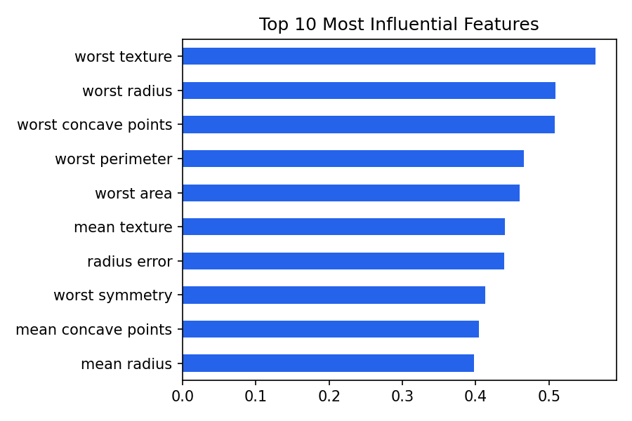
Figure 3: Ten most influential features (absolute model coefficients)
The largest coefficients belong to "worst" (largest) measurements of texture, area, radius and concave points, which agrees with clinical intuition that larger, irregular nuclei are associated with malignancy.

6. Model Serialization
The complete pipeline (scaler plus classifier) was saved in two formats to demonstrate both approaches required by the task:
- Joblib (models/model.joblib): efficient for objects containing NumPy arrays; this is the file loaded by the API.
- Pickle (models/model.pkl): Python's standard serializer, kept as an alternative and for comparison.
- Metadata (models/metadata.json): feature names, value ranges and evaluation metrics, so the API and UI stay consistent with the trained model.
joblib.dump(model, "models/model.joblib")
model = joblib.load("models/model.joblib")

Security note: Pickle and Joblib files can execute arbitrary code when loaded, so model files must only be loaded from trusted sources. Model files should also be loaded with the same scikit-learn version that created them.

7. Deployment: Flask Prediction API
The model is served by a Flask application (app.py) that loads the serialized pipeline once at start-up and exposes the following endpoints:
Method | Route | Purpose
GET | / | Web interface with a form for the 30 features
GET | /health | Health check returning status and model name
GET | /features | Feature names and observed value ranges
POST | /predict | Accepts JSON with the 30 features, returns prediction, confidence and class probabilities

7.1 Input validation
The /predict route validates every request before it reaches the model. It rejects bodies that are not JSON objects, missing features, non-numeric values, negative values and non-finite numbers, returning HTTP 400 with a descriptive message instead of crashing. Inputs are converted to a DataFrame with the exact training column order, which avoids silent feature-ordering bugs.

7.2 Example request and response
curl -X POST http://localhost:5000/predict \
-H "Content-Type: application/json" -d @sample.json

{"prediction": "malignant", "class_index": 0,
"confidence": 1.0,
"probabilities": {"benign": 0.0, "malignant": 1.0}}

7.3 Web interface
A single-page HTML interface (templates/index.html) lets a non-technical user enter measurements, press Predict, and see the result with a confidence value. It calls the same /predict endpoint through JavaScript and displays validation errors clearly. A visible disclaimer states that the tool is for education only.

7.4 Packaging and hosting
The repository includes a requirements.txt and a Dockerfile that installs dependencies, trains the model and starts the app with gunicorn, a production-grade WSGI server (the built-in Flask server is for development only). The same container can be deployed to Render, Railway, Heroku, AWS or any container platform.

8. Testing
Seven automated unit tests (tests/test_api.py, run with python -m unittest) exercise the API through Flask's test client. All seven pass.
Test | What it verifies
test_health | /health returns 200 and status "ok"
test_home_page | Web UI renders with status 200
test_predict_malignant | A known malignant sample is classified as malignant
test_predict_benign | A known benign sample is classified as benign with confidence between 0.5 and 1
test_missing_features | Incomplete payload returns HTTP 400
test_bad_values | Non-numeric value returns HTTP 400
test_no_json | Non-JSON body returns HTTP 400

The live server was also tested manually with curl for the health check, a valid prediction and an invalid request.

9. Limitations and Ethical Considerations
- The dataset is small (569 patients) and comes from one source, so performance may not carry over to other populations or imaging equipment.
- The model needs pre-computed nucleus measurements; it cannot analyse raw images.
- The system is an educational demonstration and must not be used for real diagnosis. Any clinical use would require regulatory approval, external validation and expert oversight.
- Accuracy alone is not sufficient for medical use; the balance between false negatives and false positives must be set with clinicians.

10. Conclusion and Future Work
The project achieved all of its objectives: a complete machine learning workflow was built, the model was serialized with both Joblib and Pickle, and it was deployed as a validated, tested Flask prediction API with a user-friendly web interface, supported by documentation and a Docker setup. The final model generalises well, with 97.4% test accuracy and a ROC-AUC of 0.996.
Possible improvements include threshold tuning to maximise malignant recall, model explainability with SHAP, probability calibration, adding logging and monitoring, a CI/CD pipeline that runs the tests on each commit, and moving to FastAPI for automatic API documentation and asynchronous handling.

11. Repository Structure
ml-deployment-capstone/
├── app.py Flask API + web UI
├── train.py Training, evaluation, serialization
├── models/ model.joblib, model.pkl, metadata.json
├── templates/index.html
├── tests/test_api.py
├── reports/ Figures used in this report
├── sample.json Example request payload
├── requirements.txt
├── Dockerfile
└── README.md

12. References
- Wolberg, W. H., Street, W. N., & Mangasarian, O. L. Breast Cancer Wisconsin (Diagnostic) Data Set. UCI Machine Learning Repository.
- Pedregosa, F. et al. (2011). Scikit-learn: Machine Learning in Python. Journal of Machine Learning Research, 12, 2825–2830.
- Flask documentation: https://flask.palletsprojects.com
- Joblib documentation: https://joblib.readthedocs.io

